
2016 Honda 1.5L L15B7 Engine Tested with Tier 2 Fuel – NCAT Test Report

SUGGESTED CITATION: 2016 Honda 1.5L L15B7 Engine Tier 2 Fuel – Test Data Package. Version 2018-05. Ann Arbor, MI: US EPA, National Vehicle and Fuel Emissions Laboratory, National Center for Advanced Technology, 2018.
NCAT – National Center for Advanced Technology

National Vehicle and Fuel Emissions Laboratory – Office of Transportation and Air Quality
U.S. Environmental Protection Agency

May 10, 2018

Mark Stuhldreher

Version: 05-10-18

Test: 2016 Honda 1.5L L15B7 Engine Tested with Tier 2 Fuel – NCAT Test Report
Program: Light-Duty Greenhouse Gas Test Program
Project: Mid Term Evaluation (MTE) Engine Benchmarking
Table of Contents
Purpose of Test 3
Definitions 3
Description of Test Article 3
Test Site 3
Test Cell Capabilities 4
Data Collection Systems 4
Vehicle Tethering 5
Engine Setup 6
Engine-Dynamometer Setup 7
Test Methodology 9
Test Fuel 9
Quality Procedures 10
Engine Safeties 10
Pre-Conditioning and Common Mode Check 11
Data Set Definition 11
Test Cell Procedures 11
Test Data Collection and Analysis 12
Benchmarking Details………………………………………………………………………….13
Test Phase 1: Low-Mid Loading……………………………………………………………….14
Test Phase 2: High Loading……………………………………………………………………15
Special Measurement of Fuel Consumption During Transient Operation……………………...18
Test Phase 3: Idle-Low Loading……………………………………………………………….22
Data Quality Control 23
Results 23
Uncertainty 26
References 32

Purpose of Test
The purpose of this test is to characterize the performance of a 2016 Honda Civic 1.5L L15B7 turbo engine, in particular to generate fuel map data that may be used in the ALPHA model. During the course of this testing, test methods for use in characterizations of future engines were also developed.

Definitions
Fuel map | Engine operating map that displays contours of brake specific fuel consumption (in g/kWh) on a grid of engine speeds (RPM) and engine torques (Nm)
Protection mode | An engine operation mode where the ECU retards ignition timing, limits load and/or runs excess fuel (λ<1) due to exhaust temperature limits being reached
Alpha model | Vehicle simulation model titled Advanced Light-Duty Powertrain and Hybrid Analysis.

Description of Test Article
The engine used in this project was a Honda Civic 1.5L turbo direct-injection gasoline engine. Table 1 summarizes information that describes the vehicle and engine used in this test program.

Table 1: Summary of Vehicle and Engine Identification Information
Vehicle (MY, Make, Model) | 2016 Honda Civic 4D Touring
Vehicle Identification Number | 19XFC1F9XGE000831
Engine (displacement, name) | 1.5L DOHC 16-Valve 4-Cylinder
Rated Power | 174 hp (130 kw) @ 6000 RPM
Rated Torque | 162 lb.-ft (220 Nm) @ 1700 RPM
Recommended Fuel | Regular unleaded E87
Engine Features of Interest for MTE | Direct-injection, single-scroll turbocharger, dual variable valve timing control (VTC)

Test Site
This test was performed in National Center for Advanced Technology (NCAT) Test Cell 7, but the procedure is applicable in various NCAT test cells using iTest controls and RPECS data collection.

Test Cell Capabilities
The following instrumentation, listed in Table 2, exists in Test Cell 7 although not all instrumentation listed may have been utilized during this testing.

Table 2: Instrumentation in NCAT Test Cell 7
Instrument Name | Purpose/Measurement Capabilities | Manufacturer
Dynamometer | Motoring and absorbing AC dyno | Meidensha
Torque Sensor | Measures engine torque | HBM
CVS dilution tunnel | Exhaust flow system | EPA
Coriolis fuel meter | Measures fuel flow rate | Micromotion
Laminar flow element | Measures air flow rate | Merriman
Methane cutter | Removes methane | Horiba
Emissions bench | Raw and dilute exhaust gases:  CO, THC, NOx, CH4, CO2 | MEXA

Data Collection Systems
Test cell data acquisition and dynamometer control are performed by iTest, a data acquisition system developed by A&D Technology, Inc. Test cell data including temperatures, pressures, speed and torque are logged by iTest. Engine and transmission ECU inputs and outputs are measured using the Rapid Prototyping Engine Control System (RPECS), a hardware/software package for engine control and supplemental data acquisition developed by Southwest Research Institute (SwRI). RPECS data is logged by iTest via an Ethernet connection and combined into a single output file. The engine control and data acquisition software packages are summarized below in Table 3.

Table 3: Engine Control and Data Acquisition Systems
System | Developer | Description | Data Rate
iTest | A&D Technology Inc., Ann Arbor, MI | Test cell automation hardware and software system that controls the dynamometer and some engine controls; collects test cell data; master data logger. | 10-100 Hz
MATLAB | MathWorks, Natick, MA | Software used for development of data processing algorithms for transient testing | --
RPECS | Southwest Research Institute, San Antonio, TX | Crank angle based engine control and data acquisition system that collects ECU analog and CAN data, TCU analog and CAN data, and controls torque converter lock up solenoid. | 1/engine cycle

Vehicle Tethering
The objective of this benchmarking was to characterize the engine while operating in an engine dynamometer test cell as though the engine were operating in the vehicle. The ECU in today’s vehicles requires communication with other control modules to monitor the entire vehicle’s operation (security, entry, key on, dashboard signals, etc.). Because the ECU needs signals from these modules to operate, the signals need to be extended into the test cell so the ECU can send and receive signals indicating correct vehicle operation. For this benchmark testing, the wiring harnesses were lengthened connecting the ECU in the test cell to the rest of the vehicle. As a result, the engine located in the dynamometer cell was then tethered to its vehicle chassis located outside the cell. The ECU signals were monitored by the data acquisition system. Figure 1 illustrates the tethered wiring harness.

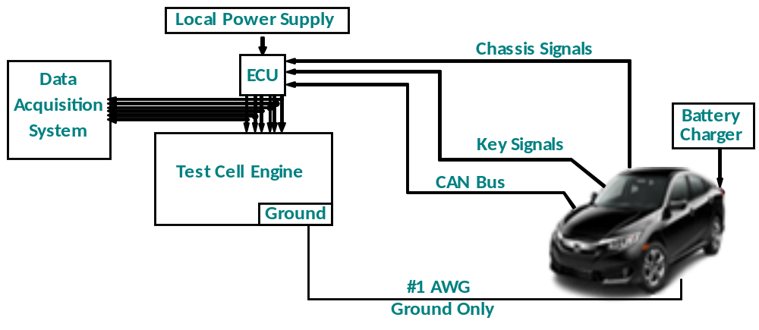
Figure 1. Vehicle and Engine Tethered Wire Harness

Engine Setup
Figure 2 illustrates the engine configuration and sensor location in the dynamometer test cell. The sensor colors shown in the upper left corner of the figure indicate which systems are monitored.
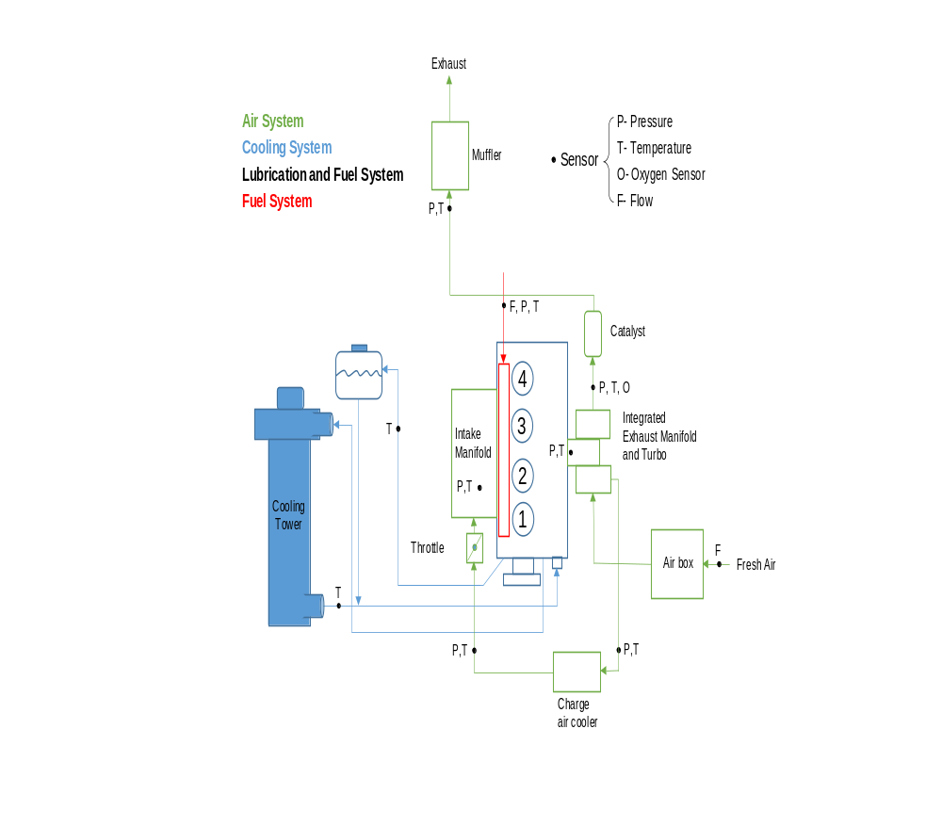
Figure 2: Schematic of Dynamometer Test Cell and the 1.5L Engine Sensor Locations Corresponding to the Identified Systems
The stock engine systems were used with the addition of instrumentation as follows:
- Intake: The stock air box and plumbing were used with a laminar flow element (LFE) connected to air box inlet.
- Exhaust: The stock exhaust system was used including catalyst and mufflers (the figure only shows one muffler). The exhaust system outlet connected to the CVS emissions tunnel via 2-inch diameter tubing. Emission tunnel pressure was controlled to CFR specifications for chassis dynamometer testing (P^{atm} +/- 1.2 kPa).
- Cooling system: The stock cooling system was used, but the radiator was replaced with a cooling tower. The stock engine thermostat was used to control engine coolant temperature. The cooling tower was controlled to 85°C by the test cell control system.
- Oil system: The stock oil cooler was connected to a chilled water system and controlled to 90°C by the test cell control system.
- Charge air cooling: During testing, engine temperatures were maintained to a level representative of real-world use, where the engine would be cooled by airflow into the engine compartment as vehicle speed increases. On-road testing of the 2016 Honda Civic identified 30-40°C as the target intercooler air temperature range for the engine. In the test cell, air charge temperature was maintained at 30 to 40°C by using the stock intercooler sandwiched to a water-to-air heat exchanger and fans. The actual temperature for each sampled data point is recorded with each data point.
- Front End Accessory Drive (FEAD): The stock belt and pulley FEAD system was used.
- Alternator: The alternator was modified for no electrical output by removing the field coils.

Engine-Dynamometer Setup
To gather data for this benchmarking program, two methods of coupling the engine to the dynamometer were needed. Direct drive shaft engine to dynamometer coupling worked best to gather most of the data. However, when idling and operating in the low rpm region of the engine’s operating map (especially below 1000 rpm), the high torsional stiffness of the rigid driveshaft tends to not allow the testing to replicate how the engine operates in a vehicle. Consequently, the second method of coupling the engine to the dynamometer through its transmission (a CVT) and torque converter is necessary for gathering data where the torque measurement is very sensitive to the engine’s torsional accelerations.
Setup without the CVT - In this method, the engine is coupled to the dynamometer via a drive shaft. Parts from a Honda Civic 1.8L powertrain were utilized to complete the setup. The flywheel from the Honda Civic 1.8L engine has the same crankshaft bolt pattern as the flywheel for the new 1.5L engine and was therefore able to be used. A manual transmission was modified by removing all the internal gear sets and incorporating a single through shaft to hold the flywheel and clutch. The manual transmission clutch disk, with a torsional spring assembly and rubber isolated driveshaft, resulted in stable torque measurements. A single HBM torque sensor was mounted inline between the transmission and dynamometer. This setup was used for testing from 1000 to 5000 rpm and allowed the engine to be started using its starter, tested full load, and declutched for engine idling.
Setup with the CVT - In this method, the engine is coupled to the dynamometer via a drive shaft through the Honda Civic’s CVT and torque converter with torque sensors utilized both before and after the CVT (as shown in Figure 3).
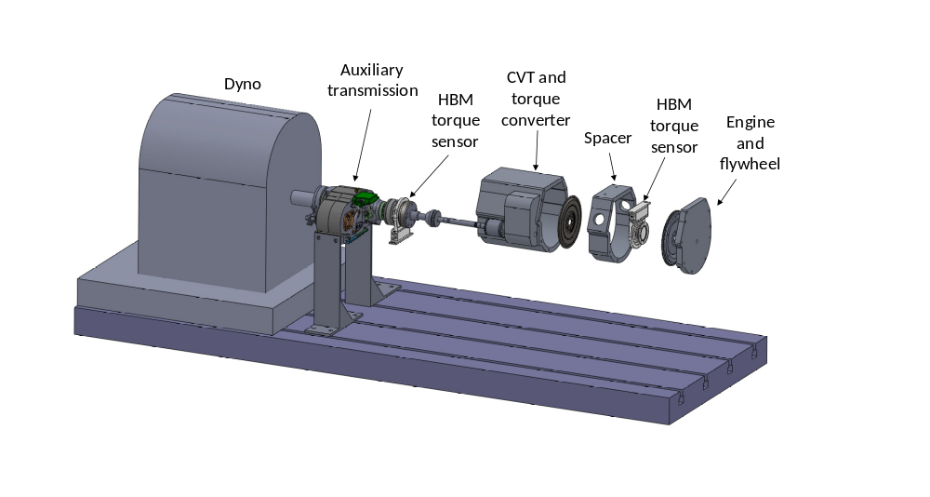
Figure 3. Engine and CVT Setup with Torque Sensors
Two HBM torque sensors are mounted inline between the engine, CVT, and dynamometer. This engine setup allows data to be gathered to compute both engine idle fuel consumption and CVT efficiency. An auxiliary transmission is mounted between the CVT and dynamometer to step down the CVT output torque for the dynamometer to absorb.
To test the engine in the low-speed/low-torque areas of operation, it is necessary to couple the engine to the dynamometer via the CVT transmission as described above. The CVT torque converter lock up solenoid can then be controlled remotely allowing the torque converter clutch to be unlocked and enable low speed operation with minimal torsional stiffness. This setup with the CVT also enables idling measurements with the transmission in park, neutral, or drive; with the torque converter locked or unlocked; and with the CVT output shaft locked or unlocked. Measurements under these various conditions accurately replicate how the engine operates in a vehicle that is decelerating or not moving.
Special consideration for measuring torque - Special care is required for measuring engine torque and other sensors that are sensitive to engine cyclical dynamics. These signals become more sensitive when mounting the torque sensor between the engine and CVT as required for the engine setup used for testing in the idle-to-low-load region shown in Figure 5. When these sensors are sampled in a time domain at 100 Hz, signal aliasing occurs and distorts the reported signal values.
These sensors cannot be correctly sampled at 100 Hz and must be sampled in the engine crank angle domain. The method consists of sampling the torque sensor output voltage with a high-speed data acquisition system, in this case RPECS, and averaging the samples over one engine cycle. The averaged value is then logged to iTest. An example torque signal aliasing of the time sampled method is shown in Figure 4. This graph was generated by logging a load sweep over 60 seconds and shows both the same torque signals, one sampled in the crank angle domain and the other sampled in the time domain.

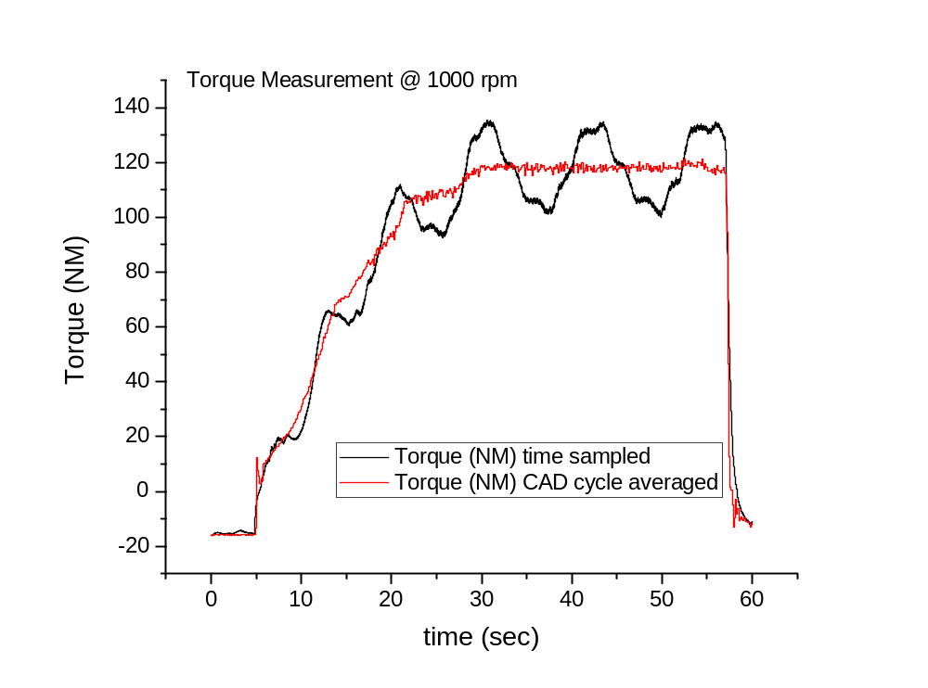
Figure 4. Engine Torque Measurement Load Sweep

Test Methodology

Test Fuel
The primary properties of the Tier 2 fuel used in this test program are shown in Table 4 below. A detailed summary of the fuel analysis performed and results measured for the Tier 2 fuel utilized in the test program can be found in the file: 6– NVFEL Fuel Analysis Report 25842.pdf.

Table 4. Fuel Properties for FTAG 25842
Parameter Description | Test Fuel Specifications  (40 CFR §86.113-04) | Reference Procedure | Measured Results | Units
Research Octane (optional) | 93 (minimum) | ASTM D2699; ASTM D2700 | 96.1 | RON
Octane Sensitivity (optional) | 7.5 | ASTM D2699; ASTM D2700 | 7.6 | RON-MON
Hydrocarbon Composition (vol %)
Olefins | 10% Maximum | ASTM D1319 | 0.8 | Vol %
Aromatics | 35% Maximum | ASTM D1319 | 30.5 | Vol %
Total Sulfur, wt.% | 0.0015-0.008 | ASTM D2622 | 36.2 | ppm
Dry Vapor Pressure Equivalent, psi (kPa) | 8.7–9.2 (60.0-63.4) | ASTM D5191 | 9.11 | psi
The following are provided for Reference Only and are not specified in the CFR
Antiknock | None | N/A | 92.3 | (RON+MON)/2
Net Heating Value | None | ASTM D3338 | 18443 | BTU/lb
Net Heating Value | None | N/A | 42.9 | MJ/kg
Alcohol Content | None | ASTM D5599 | 0.00 | Vol %
Carbon Content | None | ASTM D3343 | 0.86650 | Weight Fraction

Quality Procedures
This test program is covered by the Light-Duty Greenhouse Gas Test Program: Evaluating Potential Future Vehicle Technologies Quality Assurance Project Plan (QAPP).

Engine Safeties
Table 5 lists the limits that exist for several engine parameters. These variables were monitored to ensure component durability and operator safety.

Table 5: Engine Safety Limits
Parameter | Test Parameter Name | Units | Minimum | Maximum
Oil Pressure |  | kPa_{g} | 175
Coolant Temperature | Coolant Temp | ºC |  | 120
Engine Speed | Speed | RPM |  | 6500

Pre-Conditioning and Common Mode Check
Before testing began, the engine was warmed up. The engine was considered “warm” when the fuel flow rate and exhaust temperatures stabilized and the coolant and oil temperatures were a minimum of 90 ºC and 80 ºC respectfully. A common mode, run with the parameters given in Table 6, was repeated at the beginning of each test to expose any potential inconsistencies that could indicate equipment wear or improper instrument calibration.

Table 6: Common Mode Test Conditions and Criteria for Achieving “Warmed” State
Parameter | Test Parameter Name | Condition
Engine Speed Setting | Speed | 2000 RPM
Pedal Command Setting |  | 25%
Coolant Temperature Criteria | Coolant Temp | 90 ºC
Oil Temperature Criteria | Oil Sump Temp | 80 ºC

Data Set Definition
The data logged included torque, fuel flow, emissions, temperatures, pressures, in-cylinder pressure and OBD/epid CAN data. The steady-state data were recorded by the iTest data acquisition system. Each steady-state mode was logged to a single output file.

The final data set containing the engine mapping test parameters is provided in the test data file: 4- 2016 Honda 1.5L L15B7 Engine Tier 2 Fuel - Test Data.xlsx. The data set includes a list of the test parameters along with the variable name, description, and calibration status. Variables that are listed “Reference Only” are not calibrated to a standard but are recorded to verify the correct operation of the engine to ensure the engine and ECU are operating without any faults or a check engine light. NCAT’s test data processor also uses this data set to produce the test data plots provided in the file: 5- 2016 Honda 1.5L L15B7 Engine Tier 2 Fuel - Test Data Plots.pdf.

Test Cell Procedures
The procedure for starting up and shutting down the test cell is outlined in the file: 3b- 2016 Honda 1.5L L15B7 Engine - Test Cell 7 Startup & Shutdown Procedure.docx. This procedure describes how to activate and operate the test cell components required to run the engine. This procedure was developed during the installation of the engine and associated hardware needed for testing prior to conducting any recorded engine mapping and testing. This procedure ensures the correct start up and shutdown of the engine, the vehicle, and the test cell equipment for the engine to operate as expected in the test cell.

Test Data Collection and Analysis

Both steady-state and transient engine test data are collected during the benchmark testing. Two different test procedures are needed to appropriately replicate steady-state engine operation at low/mid loads and transient engine operation at high loads. NCAT’s benchmarking process gathers steady-state and transient test data points in the three load regions highlighted in Figure 5.
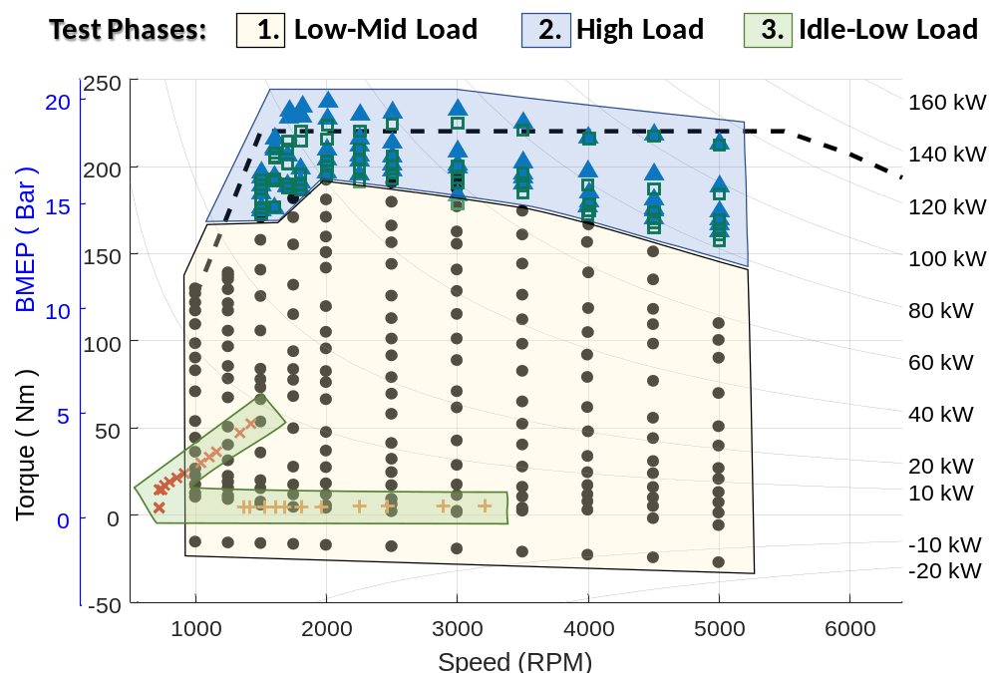
LEGEND
Core Map Steady-State Operating Points
(engine coupled to dyno, no CVT)
× | Low Speed/Near Idle Steady-State Operating Points  (engine coupled to CVT in drive)
Low Speed/Near Idle Steady-State Operating Points
(engine coupled to CVT in neutral)
 | High Load Transient Operating Points - Initial Value
 | High Load Transient Operating Points - Final Value
 | Maximum Torque Curve (from published data)
Figure 5. Three Load Regions and the Associated Engine Mapping Operating Points
The core map steady-state operating points in the Low-Mid Load region (the black dots in Figure 5) are collected using steady state mapping procedures and are below the region where enrichment was first observed in this benchmarking program. These points generally have stable consistent engine controls (e.g. spark timing, valve timing, start of injection), allow the use of relatively slow response fuel flow measurement systems over a 30-second data collection window, and are therefore straightforward to analyze and report.

The high load transient operating points in the High Load region (the blue triangles and green squares in Figure 5) are defined as the region where enrichment is observed. In this region, data cannot be collected with steady state procedures due to the transient nature of the engine control, which is employed to protect the engine from excessively high temperatures, avoid preignition at low speed/high load, or avoid knock at high speed/high load. The ECU avoids these damaging effects by transiently adjusting the engine control parameters to lower temperature, often at the expense of fuel consumption and efficiency, through control techniques such as spark retard and fuel enrichment. To properly benchmark the engine and monitor its changing control and performance in the high load region, a transient test procedure is required. Characterization of the engine’s transient behavior at high load is most important when creating engine fuel maps which can be used to estimate “off-cycle” emissions that occur when the vehicle is operated above power levels needed over the regulatory certification cycles (FTP, Highway, and US06).

Test data for engine operating points in the Idle-Low Load region that are at low speeds or near and at idle conditions (the red x’s and orange plus signs in Figure 5) cannot be collected acceptably with the direct coupling arrangement of the engine to the dynamometer typically used for mid and high load testing due to the high torsional stiffness of the driveshaft and the high rotational inertia of the dynamometer. Gathering data in the low speed/low torque area of the engine map is accomplished by incorporating a transmission (CVT or automatic) into the test setup producing driveline behavior similar to that found in the vehicle.

Note the differences between engine testing in the High Load region and Low/Mid Loads region result in different preconditioning strategies before test data are recorded. When data from the two procedures are merged into a single data set, this may result in small discontinuities in system temperatures between adjacent points. An example of this can be seen in the CAC Outlet Temp plot provided in 5- 2016 Honda 1.5L L15B7 Engine Tier 2 Fuel - Test Data Plots.pdf.

Benchmarking Details
To gather the complete set of test data shown in Figure 5, the engine was operated with and without the CVT in the three key Test Phases identified in Table 7. Each different test phase is discussed in more detail to explain how each of the various types of data were measured and processed to develop a complete fuel efficiency map.
Table 7: Summary of the Engine Benchmarking Methods and Procedures
Test Phase | Engine Operation | Data Collection | Data Processing
1 Low-Mid Loading | 30 sec avg.  (Stoichiometric) | Steady-State (without CVT) | Steady-State Average  (using iTest)
2 High Loading | Stab test (Stoich.Enriched) | Transient  (without CVT) | Transient Intervals  (using Matlab)
3 Idle-Low Loading | 30 sec avg.  (Stoichiometric) | Steady-State  (with CVT) | Steady-State Average  (using iTest)

Test Phase 1: Low-Mid Loading
To collect the core map steady-state operating points (black dots) in Figure 5, the engine is configured without its CVT and tested in steady-state operation at low to mid loads where the Air/Fuel ratio remains stoichiometric at speeds from 1000 to 5000 rpm using the steady-state data collection and steady-state processing with the iTest system.
Data points for the low-mid load region (black dots) are typically collected first during the engine benchmarking process because these samples help ensure the engine is setup correctly with no unexpected resonance frequencies, is operating within acceptable temperature ranges, and is tethered appropriately so the OBD II system is not showing current or pending malfunction codes. The engine to dynamometer setup for this portion of the benchmarking is faster since the transmission of the vehicle is not yet needed.
Engine Operation – For this phase of testing the engine is operated using a test procedure to appropriately characterize steady-state engine operation at low/mid loads. The core of the steady state engine map contains the primary operating range of the engine, which is characterized by stoichiometric operation and spark timing which will result in the highest efficiency. The stability and repeatability of engine operation in this load region allows for straightforward collection of steady state measurements on an engine dynamometer.
Data Collection – Engine operation consists of holding the engine at a fixed speed (with the engine dynamometer) and commanding a fixed pedal position. Operation at this point is held until the engine torque, fuel flow, and exhaust temperature reach a stable condition. The data is then logged for 10 seconds at 10 hertz sampling and averaged using iTest. For each engine speed, the sequencing procedure steps through an array of pedal commands from low to high (0 to 100% pedal position) and records the steady-state data for each test point. The engine speed is then incremented to the next highest rpm and the torque array is repeated. Generally, mapping points are denser in the lower engine speeds and loads areas of operation.
While this engine did not consume fuel at all the zero pedal test points, an accurate measurement of torque is necessary to ensure an appropriate amount of drag is placed on the drivetrain during simulation of coasting conditions. These data are gathered to determine the energy consumed during coasting, which would not be energy that would be available to be captured in a vehicle featuring a hybrid powertrain or alternator regeneration technology.

Test Phase 2: High Loading
To collect the high load transient operating points (blue triangles and green squares) in Figure 5, the engine is configured without its CVT and tested in transient operation at high loads where the Air/Fuel ratio transitions to enriched to protect the engine at speeds of 1000 to 5000 rpm using the transient data collection procedure and the initial-final interval post-processing.
Data points for the high load region are gathered in this phase of the benchmarking which pushes the engine to operate at its highest torque levels across all engine speeds. No CVT is used in the engine-dynamometer setup for this phase of testing.
When operating in high load conditions, the engine ECU controls several parameters such as A/F ratio and spark timing differently depending upon the speed and load on the upper limits of the engine performance. Generally, the engines operate at a stable stoichiometric A/F ratio idle to approximately 70% load. Above 70% load, the engine ECU will transition the A/F ratio from stoichiometric to enriched as needed to protect the engine from excessive heat.
Engine Operation - For this phase of testing the engine is operated at high loads near and including wide-open throttle (WOT) using a special test procedure to activate the transient response that occurs when the engine is protecting itself at high loads. While NCAT has successfully used a sweep test in some previous test programs to establish the maximum torque curve used for simulation, our experience with naturally aspirated and turbocharged gasoline engines tells us that sweep tests often under-predict the maximum achievable torque of the engine. This is primarily due to the high temperatures resulting from the relatively slow rpm sweep (5-10 seconds) and the subsequent de-rating due to engine protection controls. For this reason, NCAT ran the high load transient procedure to determine WOT and used the sweep test to better understand protection controls and to potentially fill in some data gaps for the lower speed range of the WOT curve.

The minimum high load points are identified during the steady state testing done in Test Phase 1, when the A/F ratio is noted to change from stoichiometric to enriched during its stability and steady-state logging time period of approximately 30 seconds. For each transient test point, the accelerator pedal is held at about 1/3 load and the engine is allowed to stabilize. The accelerator pedal is then ramped at a programmed one second rate to the desired torque for that test point (NCAT refers to this portion as the “stab test”). This engine operating condition is maintained until a time limit is reached, generally about 30 seconds worth of data is collected. The engine is stepped through an array of specified speed and load points in a sequence similar to the steady state procedure.
Data Collection – For each data point, the data are logged continuously at 100 Hz while the engine torque is ramping up to the desired torque value and while operation is held at that point for 30 seconds. The data are then post-processed to determine the peak torque, final torque, transition time from stoichiometric to enriched, brake thermal efficiency (BTE), and other key engine criteria. A graphic example of a transient data set is shown in Figure 6.
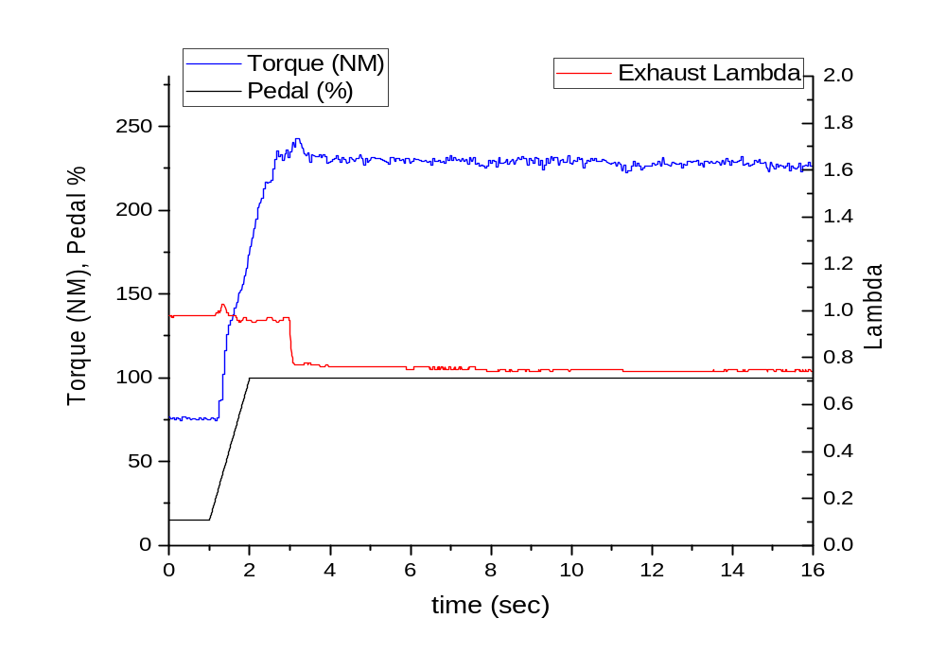
Figure 6. Example of Data Collected During Transient Test

Special Post-Processing Necessary for Transient Data Points - Once the roughly 30 seconds of transient data have been collected for all the high load points, the captured data streams must be post-processed to determine the final results. These results will be used later to develop brake specific fuel consumption (BSFC) and brake thermal efficiency (BTE) maps suitable for use in vehicle simulation models.

The basic calculations for transient data points include a straight-forward averaging of several repeat measurements. However, before the averaging can be done for these transient points, the data set for each data point must be analyzed to determine the two specific time intervals that occur when the engine is at or near its high load operating torque. These two-time intervals occur around the time the engine transitions from stoichiometric to enriched operation. The blue Torque line in the top chart of Figure 7 illustrates the transient operation of the engine torque that occurs after the torque achieves ~200 Nm due to the transition to enriched operation. The red line in the middle chart in Figure 7 shows the change in the Exhaust Lambda (air-fuel equivalence ratio).

Initial and Final Intervals: To characterize the high load region of operation, the goal was to define an initial time window after the target high load torque is achieved while the engine is still in stoichiometric operation, and then a final time window after control stabilizes to a long term steady state value in enriched operation. Once the two intervals are determined then post-processing computes the straight-forward average of the measurements in the interval.

The average values in these two intervals bookend operation in the high load region. The “initial” interval (blue highlighted area in Figure 7) contains the torque and fuel consumption data measurements representing how the engine operates when it first achieves operation at a high load operating point. The criteria to select the initial interval begins with defining the time when the engine first achieves the torque level targeted for the test point, labeled t₀ in the plots below. The initial data window, highlighted blue below, is selected by finding a segment between t₀ and t₀ plus two seconds where maximum torque is sustained for at least 0.5 seconds.

The “Final” high load interval (green highlighted area in Figure 7) contains the stable torque and fuel consumption data measurements representing how the engine operates when operated at that high load operating point for a sustained amount of time. The final high load interval is selected by identifying the final segment where data from the fuel flow meter are stable. If the test contains a significant amount of enriched operation, this window is constrained to start after enrichment is first observed.
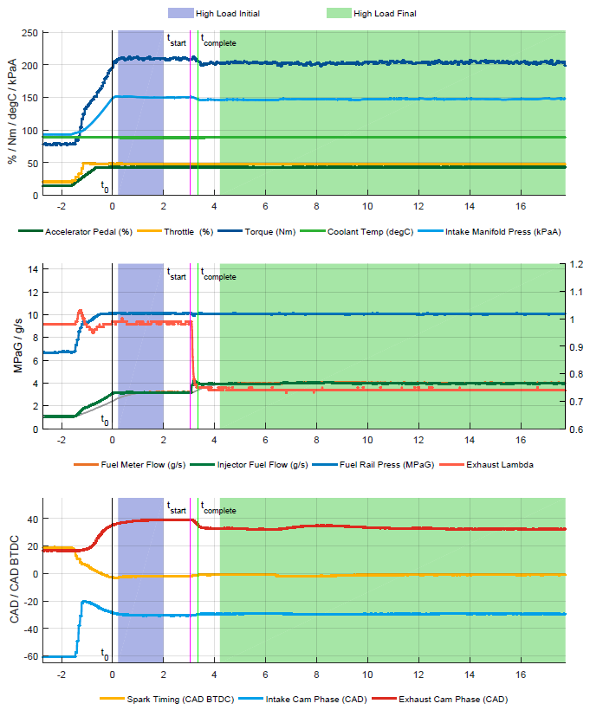
Figure 7. Example High Load Test Showing Several Pertinent Parameters and the Windows of Data Selected

Special Measurement of Fuel Consumption During Transient Operation

Typically, when benchmarking an engine, steady-state operation allows for the straightforward measurement of fuel consumption either by a fuel flow meter or by exhaust emissions. NCAT generally uses a fuel flow meter when benchmarking engines. Due to transport lag and other time delays, these two measurement techniques are unable to accurately quantify the amounts of fuel consumed over short periods of engine operation. Consequently, NCAT uses a third technique that uses fuel injector data to measure how much fuel is consumed.
By capturing detailed measurements of fuel injector pulse duration and fuel rail pressure during steady state testing, an injector calibration can be constructed to then estimate fuel consumption. For improved accuracy, the fuel rail pressure is measured via a high-speed data acquisition system synchronously with the crankshaft to minimize the distortion caused by rapid fluctuations in pressure. The textbox shown in Figure 8 labeled “Injector Fuel Flow Correlation” explains the method of injector fuel flow correlation that was developed for this testing.
Injector Fuel Flow Correlation
The relationship between fuel rail pressure, injection duration and injected fuel quantity for a single injection event follows from the classic orifice equation and is shown in the equation below.
$$q_{fuel}=m∙\left(\sqrt{P_{rail}}∙{dur}_{inj}\right)+b$$
Where: $q_{fuel}$ = injected fuel quantity (mg)
$P_{rail}$ = High pressure fuel rail pressure (MPa)
${dur}_{inj}$ = Injector open duration (ms)
The calibration constants m (slope) and b (offset) can be determined via linear regression. The figure below shows an example of the relationship using data obtained testing a Honda L15B7 1.5L turbocharged engine.
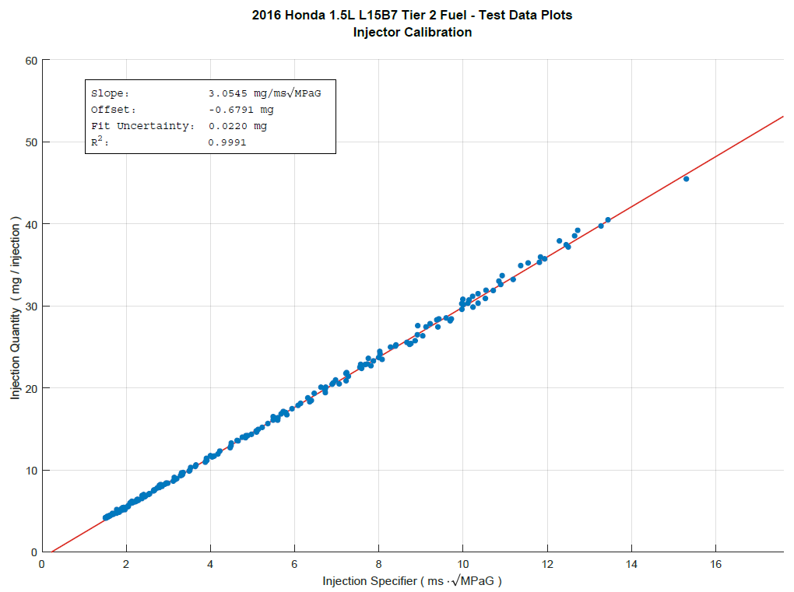
Figure 8. Injector Fuel Flow Correlation
Post-processing the average fuel consumption for each data point uses fuel meter values, unless those instantaneous readings become unstable, at which point the processor substitutes injector measurements to compute the average.

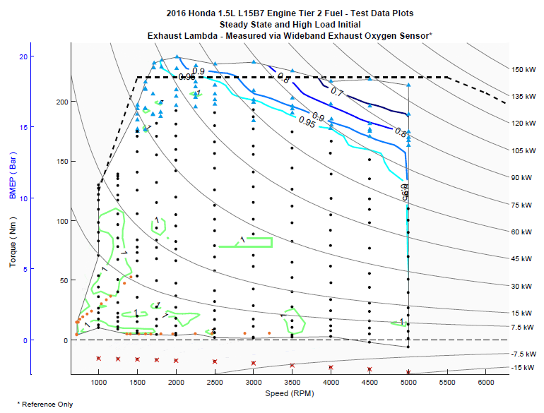

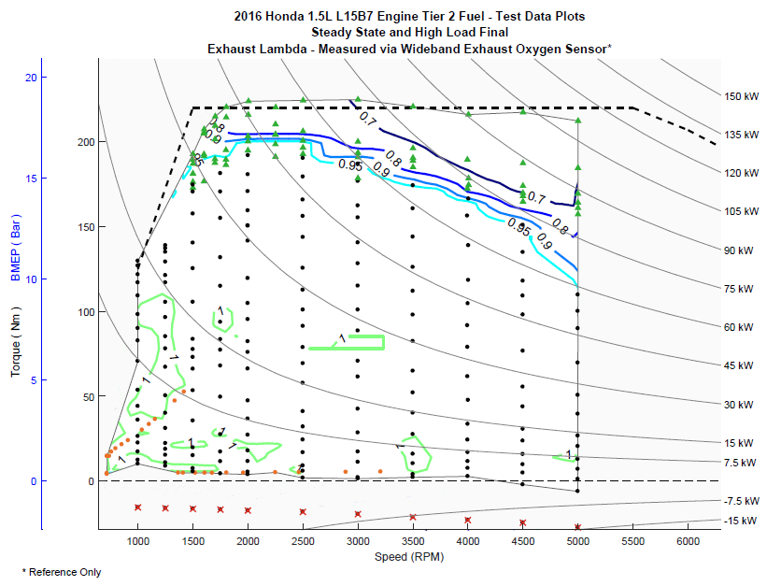
Figure 9. Exhaust Lambda in Initial and Final Intervals of Transient High Load

Figure 9 shows a summary of how lambda changes between these initial and final intervals. The steady-state average torque, speed, and fuel flow points, shown previously as black dots in Figure 5, were combined with the average initial and final transient torque data, shown previously as blue triangles and green squares in Figure 5, to generate base contour maps such as lambda and BTE.
The top chart in Figure 10 illustrates the BTE map using the high load “initial” torque data points (blue triangles). The bottom chart in Figure 10 illustrates the BTE map using the high load “final” torque data points (green triangles).
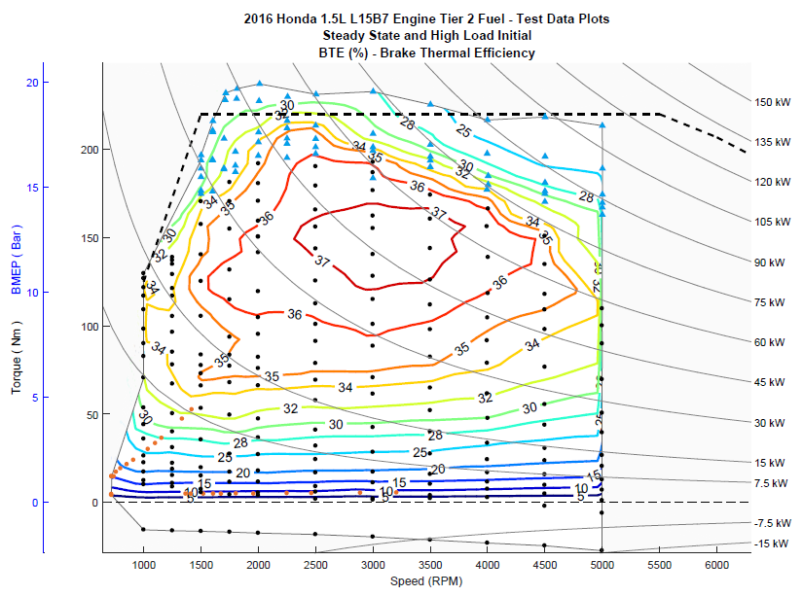
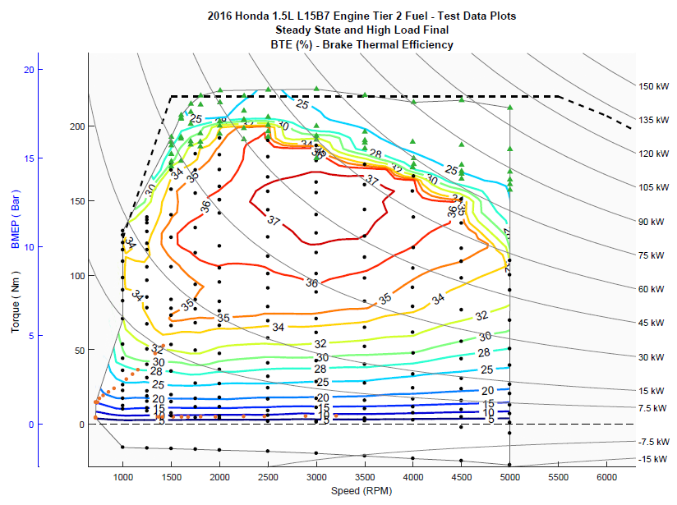
Figure 10. BTE in Initial and Final Intervals of Transient High Load

Test Phase 3: Idle-Low Loading
The engine is configured with its CVT, tested in steady-state operation at low torque loads where the A/F ratio remains at stoichiometric at speeds from idle to around 3000 rpm, and used the steady-state data collection and steady-state processing within the iTest data acquisition system for the red x and orange + data points in Figure 5.
Data points for the idle-low load region of engine operation shown in Figure 5 are gathered in this final phase of the engine benchmarking by coupling the engine with its torque converter to the dynamometer because the engine is more sensitive to torsional accelerations. To connect to Honda’s torque converter, the engine was simply coupled to a complete 2016 Honda Civic CVT.
Engine Operation: Testing in the idle-low load region of the map is conducted in two parts. In the first part of this testing, the steady-state engine and CVT operation consists of controlling the engine speed/torque settings using a pedal sweep with the CVT shift mechanism in neutral and the CVT output shaft held at zero rpm by the dynamometer. The torque converter is unlocked and controlled by the ECU. The first data point of this sweep represents the engine’s idle point (pedal equal zero) with the CVT in neutral. Increasing the pedal steps though an array of points as shown by the orange +’s points in Figure 5 and Figure 11 below.

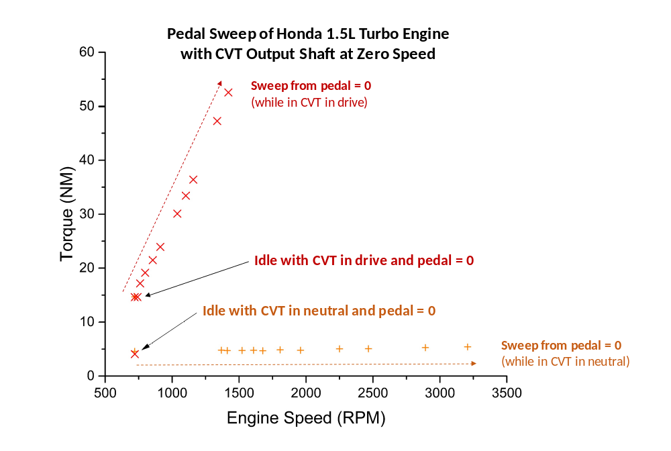
Figure 11. Test Phase 3 with Idle-Low Loading

In the second part of the idle-low load testing, the steady-state engine and CVT operation consists of controlling the engine speed and torque settings using a pedal sweep with the CVT shift mechanism in drive and the CVT output shaft held at zero rpm by the dynamometer. The torque converter is unlocked and controlled by the ECU. The first data point of this sweep represents the engine’s idle point (pedal equal to zero) with the CVT in neutral. Increasing the pedal steps though an array of points as shown by the red “x” points in Figure 5 and Figure 11.

Data Collection – The test procedures for testing in this region requires engine operation at each point the pedal position is held until the engine torque, fuel flow, and exhaust temperature stabilize for approximately 30 seconds. Data is then collected at 10 Hz for 10 seconds.

Data Quality Control
A test parameter subset of data focused on engine efficiency was extracted from the iTest data log for review. Descriptions for the test parameter list are provided in the test data set for reference. The data set is analyzed for outlier data based on the statistical data included in the iTest data logger file. In addition, the data set is plotted and reviewed using an NCAT developed contour plotting routine. During these reviews, any outliers may be removed as needed based upon the discretion of the internal review team.

Results
The final test data set containing the engine mapping test parameters is provided in the file: 4- 2016 Honda 1.5L L15B7 Engine Tier 2 Fuel - Test Data.xlsx. The average torque, speed, and fuel flow measurements were used to determine a grid and generate fuel contour maps for Brake Specific Fuel Consumption (BSFC), shown in Figure 12, and Brake Thermal Efficiency (BTE), shown in Figure 13. Additional contour maps for all of the test data measurements are provided in 5- 2016 Honda 1.5L L15B7 Engine Tier 2 Fuel - Test Data Plots.pdf.

The benchmarking results from this testing were provided to the ALPHA model to perform full vehicle simulations over several drive cycles and vehicle road loads. Additional details pertaining to this modeling and the results obtained are described in the attached SAE paper SAE 2018-01-0319 Benchmarking a 2016 Honda Civic 1.5-liter L15B7 Turbocharged Engine and
Evaluating the Future Efficiency Potential of Turbocharged Engines. [1]

The calibration of this engine is such that zero pedal position results in no fuel injection (i.e., motoring), and a minimal increase in pedal position will result in approximately zero shaft torque: thus, none of the test data points reflect fuel injection events resulting in a negative shaft torque. If operational data at negative shaft torque is required, care should be taken in interpolating between recorded data points. For example, fuel rail pressure decreases at low torques, but increases while motoring, due to fuel being trapped in the rail. Were this engine calibrated to run at negative torques, it is unlikely the fuel rail pressure would be the linear interpolation of the values at zero torque and motoring.
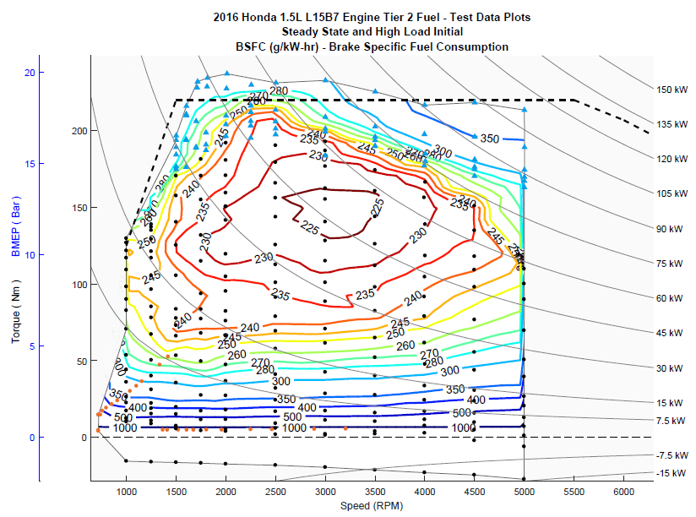
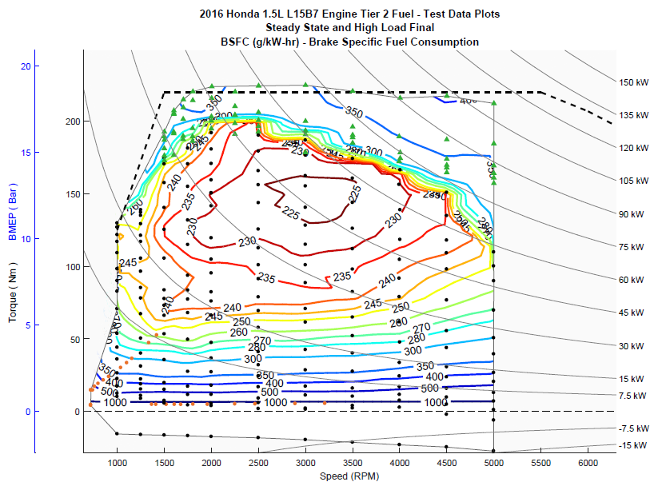

Figure 12. BSFC in the Initial and Final Intervals
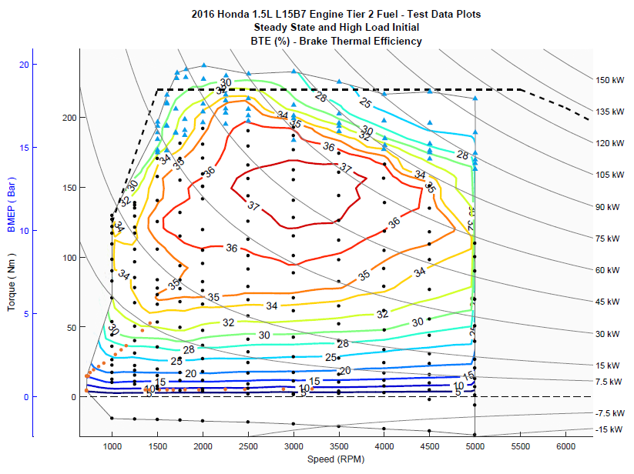
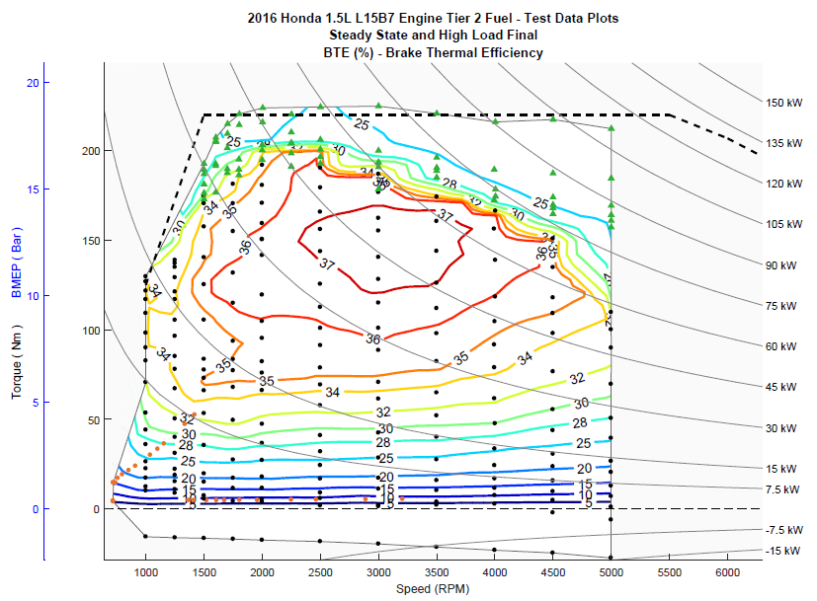

Figure 13. BTE in the Initial and Final Intervals

Uncertainty

Sensor/signal uncertainties
The uncertainties of the signals [u(signal)] in the data set can be based on (a) the uncertainty associated with the calibration standard, (b) the uncertainty of the sensor calibration [u(calibration)], and (c) the uncertainty of the signal during operation [u(operation)]. The uncertainty associated with the calibration standard is assumed to be negligible when compared to other uncertainties and thus this uncertainty is not considered for this calculation.

To determine the uncertainty of the sensor calibration, past calibration records were assessed and the difference between the standard and measured quantities were used to calculate uncertainty. If the sensor output and standard matched exactly, the uncertainty was assumed to be associated with the last digit of accuracy of the output. For example, the speed signal, which reads to the nearest rpm, was assumed to have an uncertainty no less than that of a uniform distribution of width = 1 rpm; i.e., 0.289 rpm.

In the special case of the fuel measurement during transient operation, where the injector calibration procedure was used to determine the final fuel flow, an additional term was added to account for the uncertainty associated with the additional calibration step.

To determine the uncertainty of the signal during operation, the standard deviations for each signal were recorded for speed, torque, and fuel flow as each mode was taken. From this, the uncertainty was calculated as
$u=σ/{\sqrt{n}}$
Where n is the number of individual data points averaged to create the mode. Raw data are nominally read once per engine cycle, so assuming a 10 second mode, n = (Engine rpm)/6. The operational uncertainty of the signals is calculated for each mode. The nominal uncertainty for each signal is given in Table 8, using an average u(operation) for each signal.

Table 8: Standard Uncertainties for Signals
Signal | u(calibration) | u(operation) average (ref) | u(signal)
Speed (rpm) | 0.289 | 0.0878 | 0.302
Torque (Nm) | 0.125 | 0.0512 | 0.135
Fuel (g/sec) - steady | 0.0100 | 0.000728 | 0.0100
Fuel (g/sec) - transient | 0.0100 and 0.0397  = 0.0409 | 0.000728 | 0.0409

Testing uncertainty
In addition to the uncertainties associated with each signal, there may be an overall uncertainty associated with the repeatability of the testing procedure and the engine operation. To estimate this uncertainty, a number of common modes were run at a consistent speed and load; the point initially chosen was at 2000 rpm and 150 Nm. At this operational point, it was found that spark timing would change dynamically to prevent knock (see Figure 14). The timing change also affected fuel required to produce the require load, and thus efficiency. In comparison, at lower loads, the timing change was minimal (Figure 15). The change in spark timing due spark is reported by the ECU and was recorded, and thus those modes where the spark is being dynamically altered can be identified.

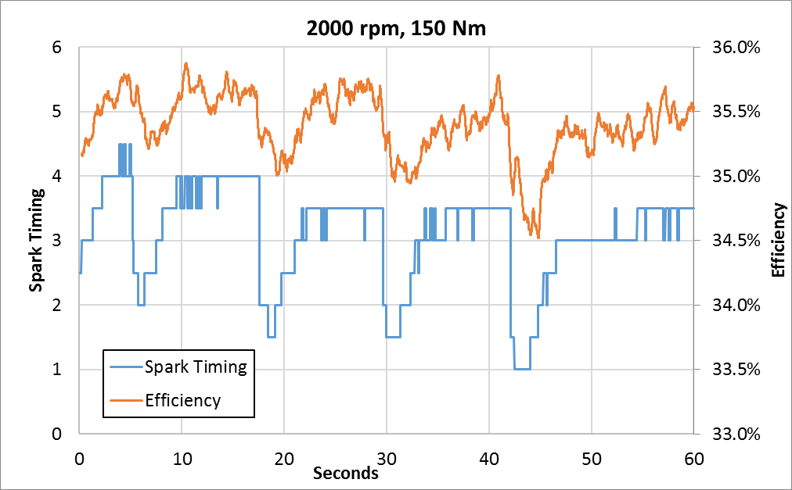
Figure 14. Dynamic Change in Spark Timing & Efficiency (Tier 2 Fuel)

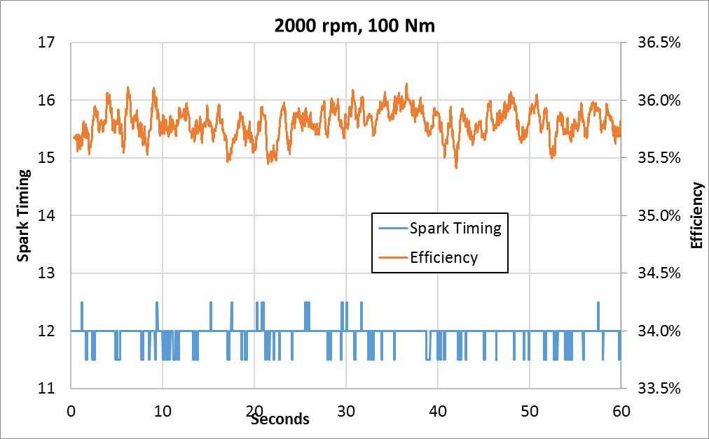
Figure 15. Spark Timing & Efficiency at Lower Loads (Tier 2 Fuel)
This variation in engine operation during testing affected the calculated engine efficiency numbers. Figure 16 shows ten ten-second modes at 2000 rpm and 100 Nm and twelve ten-second modes at 2000 rpm and 150 Nm. While the essentially stable spark timing at 100 Nm maintains a constant efficiency, the variable timing at 150 Nm affects the efficiency. The standard deviation of the efficiency at 100 Nm is 0.053% (0.350 g/kWh BSFC), while the standard deviation of the efficiency at 150 Nm is 0.216% (1.467 g/kWh BSFC).

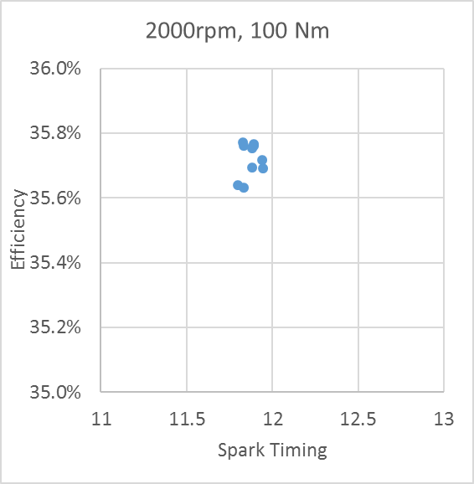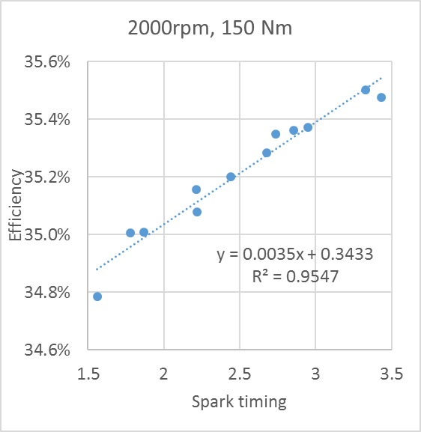
Figure 16. Spark Timing & Efficiency Relationship of 10-Second Modes (Tier 2 Fuel)

As an estimate of the magnitude of the uncertainty due to the change in spark timing, the difference in uncertainty between these two cases is:
$$u\left(spark\right)= \sqrt{u^{2}\left(150 Nm\right)-u^{2}\left(100 Nm\right)}$$
Or sqrt(0.216² – 0.053²) = 0.210% in efficiency and sqrt(1.467² – 0.350²) = 1.424 /kWh BSFC in BSFC. This magnitude of uncertainty can be used in the final uncertainty calculation below.

Uncertainty of BSFC
The variation of engine BSFC is thus calculated by:

$$u\left(BSFC\right)= \sqrt{{\left(\frac{∂BSFC}{∂q}\right)}^{2}{\left[u\left(q\right)\right]}^{2}+{\left(\frac{∂BSFC}{∂T}\right)}^{2}{\left[u\left(T\right)\right]}^{2} +{\left(\frac{∂BSFC}{∂ω}\right)}^{2}{\left[u\left(ω\right)\right]}^{2} +{\left[u_{e}\left(BSFC\right)\right]}^{2}}$$
or
$$u\left(BSFC\right)= \sqrt{{BSFC}^{2}\left[{\left(\frac{u\left(q\right)}{q}\right)}^{2}+{\left(\frac{u\left(T\right)}{T}\right)}^{2}+{\left(\frac{u\left(ω\right)}{ω}\right)}^{2}\right]+{\left[u_{e}\left(BSFC\right)\right]}^{2}}$$

Where the testing uncertainty due to spark is either zero where no knock retard is indicated, or 1.424 g/kWh.
Uncertainty of BTE
The derivation of the uncertainty of thermal efficiency is similar, with a testing uncertainty (related to spark) of 0.21% efficiency. The uncertainty in measurement of the fuel heating value is assumed to be small compared to other uncertainties. Assuming u(HV) = 10 BTU/lb,

$$u\left(EFF\right)= \sqrt{{EFF}^{2}\left[{\left(\frac{u\left(q\right)}{q}\right)}^{2}+{\left(\frac{u\left(T\right)}{T}\right)}^{2}+{\left(\frac{u\left(ω\right)}{ω}\right)}^{2}+3.1*{10}^{-7}\right]+{\left[u_{e}\left(EFF\right)\right]}^{2}}$$

Standard uncertainties are analogous to standard deviations, such that it would be expected that, for a given set of data, the “true” value of a parameter would fall within +/-1u_{c} for 68% of the data points, the “true” value of a parameter would fall within +/-2u_{c} for 95% of the data points, and the “true” value of a parameter would fall within +/-3u_{c} for 99.7% of the data points. The calculated uncertainty for both the BSFC and BTE measurements are shown in Figures 17 and 18.
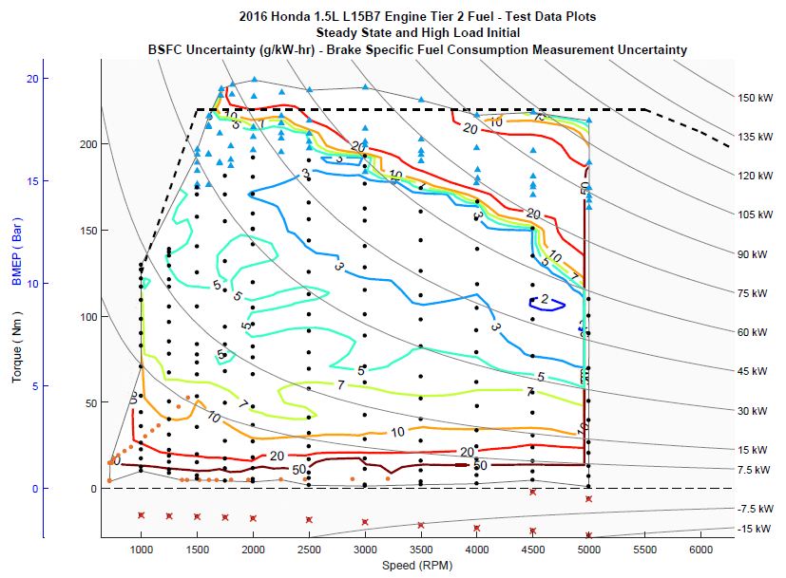
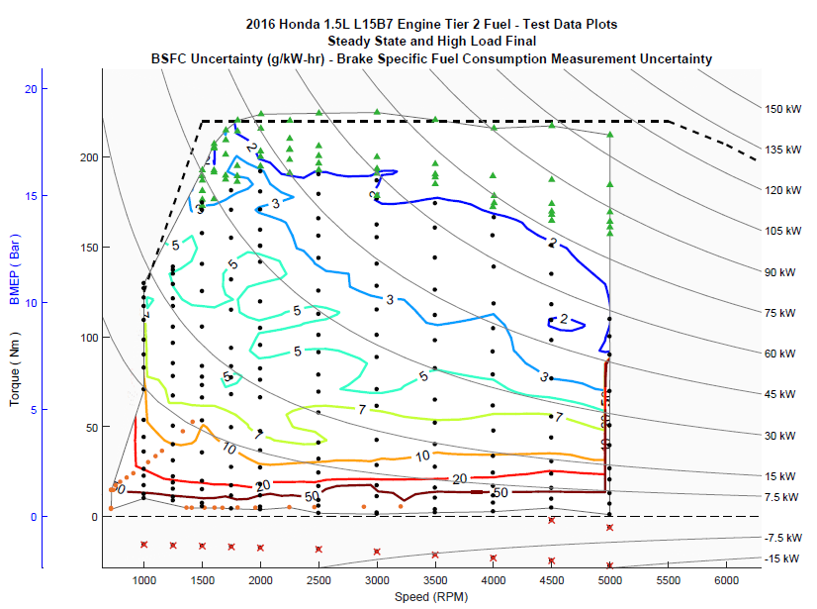
Figure 17. BSFC Uncertainty

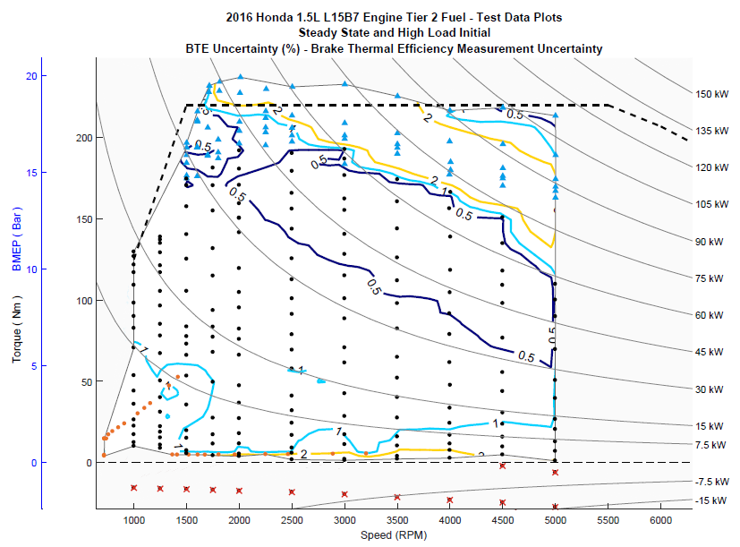
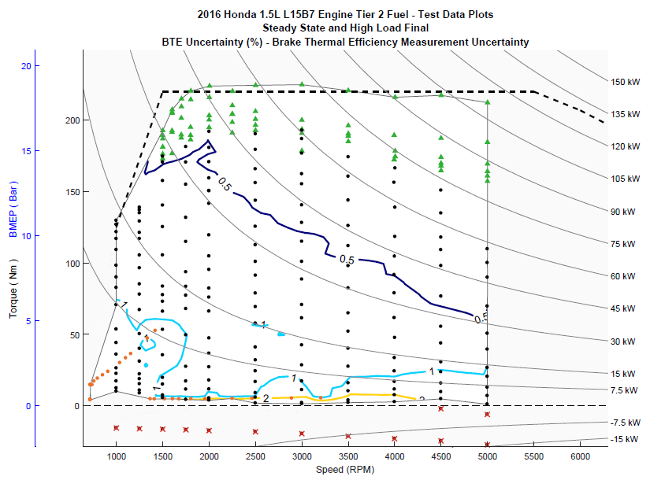
Figure 18. BTE Uncertainty

References
[1] Stuhldreher, M., Kargul, J., and Barba, D., McDonald, J. et al., “Benchmarking a 2016 Honda Civic 1.5-liter L15B7 Turbocharged Engine and Evaluating the Future Efficiency Potential of Turbocharged Engines,” SAE Technical Paper 2018-01-0319, 2018, doi:10-4271/2018-01-0319.

